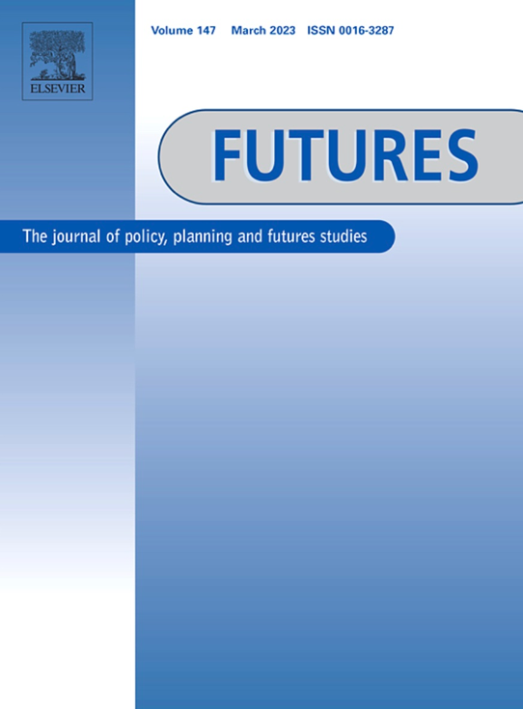
Between ‘muddling through’ and ‘grand design’: Regaining political initiative – The role of strategic foresight

Mathew J. Burrows ª, Oliver Gnad ^{b}

Full version available here: https://www.sciencedirect.com/science/article/abs/pii/S0016328717300083?via%3Dihub

Abstract
After the end of the Cold War, Western intellectuals depicted a future world that would follow Western values and adopt the liberal-democratic order. These Grand Designs proved to be misleading and even became obstacles in adapting to a world that is polycentric in design and increasingly volatile, uncertain, complex and ambiguous in nature. Ideological myopia was not the only factor that delayed a timely adaptation to a changing geopolitical environment; bureaucratic obstacles and psychological factors also came into play. This was the backdrop for what in Europe was perceived as strategic surprises (Arabellion, Ukraine/Crimean, Syria, IS) or as disruptive political developments (Brexit, US Presidential election). Addressing Europe’s five most important partner regions (Russia/Ukraine, MENA, Turkey, USA, China), the Dahrendorf Foresight Process was initiated as a pilot project to improve the EU’s foresight capabilities. It applied a four-step methodological approach to question current strategic thinking and to develop narratives of alternatively plausible futures in the EU’s relationship with these regions. In stressing the importance of an early warning (indicator-based) system to make strategic foresight applicable for day-to-day politics and administrative processes, reference is being made to the ‘Global Trends 2030′ report of the US National Intelligence Committee (NIC).

